**Tribhuvan University**

**Institute of Science and Technology**

**Proposal On**

**INVESTIGATING AND FORECASTING TEMPERATURE DISTRIBUTION OF KATHMANDU CITY**

**Submitted by**

**RAMKRISHNA PUDASAINI**

**Roll: 24**

**Submitted To**

**Prof. Dr Ramesh Kumar Joshi**

School of Mathematical Sciences

Kirtipur, Kathmandu, Nepal

May 2024

# **Table of Content**

# 

**Table of Content ii**

**List of Figures iii**

**List of Table iv**

**INTRODUCTION 1**

**Problem Statement 2**

**Background 3**

**State Space: 3**

**Overview of Markov Chain Monte Carlo (MCMC) Approach 3**

**Objectives 4**

**Literature Review 5**

**Methodology 6**

**Data Collection 6**

**Algorithms 6**

**Expected Outcomes 8**

**Working Schedule 9**

**References 10**

# 

# **List of Figures**

# 

Fig 1: Markov Chain Model Example ---------------------------------------------- 3

Fig 2: Block Diagram of system workflow ---------------------------------------- 7

# **List of Table**

Table 1: Working Schedule of the project ---------------------------------------------- 9

# INTRODUCTION

At the elevation of approximately 1400 meters above the sea level within the latitude 27.700769, and the longitude 85.300140 lies the Kathmandu city, the capital city of Nepal. With a rich cultural heritage, vibrant city life, and rapid urbanization, Kathmandu City serves as the political, economic, and cultural hub of Nepal. However, like many urban centers, Kathmandu faces various environmental challenges, including air pollution, rapid population growth, and climate change impacts.

Temperature is a key climatic variable that influences various aspects of urban life, including public health, energy consumption, agriculture, and infrastructure planning. Understanding the distribution of temperature within Kathmandu City is crucial for enhancing the city's resilience, improving quality of life, and identifying extreme temperature events and minimizing risk associated with temperature extremes. Governments can also use this knowledge for initiating climate adaptation strategies plans.

# Problem Statement

Studying temperature in Kathmandu is super important because it affects everything in the city. It's not just about hot or cold days; temperature plays a big role in how healthy we are, how much energy we use, and even how we plan things like roads and buildings.

Understanding temperature in Kathmandu gives us a lot of useful information. We can see how it affects people's health, how much energy is needed, and even how farmers grow crops. This helps us make smart decisions about how to make the city better and safer for everyone.

Kathmandu is growing fast, and there are a lot of environmental issues to deal with. Knowing about temperature helps us prepare for extreme weather events, like hot days or sudden cold snaps. This way, we can protect people and keep them healthy.

When we understand temperature patterns, we can also help the government plan temperature estimations. They can make sure there's enough energy for everyone, and they can make changes to keep the city safe from climate change. It's all about making Kathmandu a better, safer place to live for everyone

# 

# Background

### **State Space:**

State space in the context of temperature historical data refers to the representation of the system's dynamics over time. It involves defining the possible states that the system can be in at any given time, as well as the transitions between these states.

In the case of temperature historical data, the state space could be defined by the range of temperatures observed over time. Each temperature measurement or time interval could represent a state within this space. The transitions between states could represent how the temperature changes over time, whether it's increasing, decreasing, or remaining constant.

State space models are often used in time series analysis to understand and predict the behavior of dynamic systems like temperature variations. They can be particularly useful in forecasting future temperatures based on past observations and understanding the underlying dynamics driving temperature changes.

### **Overview of Markov Chain Monte Carlo (MCMC) Approach**

The Markov Chain Monte Carlo (MCMC) approach is a powerful statistical technique used for sampling from complex probability distributions. By iteratively generating samples from a target distribution, MCMC methods allow researchers to estimate parameters, make predictions, and conduct inference in a wide range of applications, including climate science.

Markov chain is the probabilistic model describing a sequence of possible events where the probability of each event depends only on the state attained in the previous event. In simpler terms, the next step in the sequence depends only on the current state, not on the states that came before it. In this study, we employ MCMC techniques to analyze the temperature distribution of Kathmandu City and forecast the temperature for 2024 using available time series data.

Fig 1: Markov Chain Model Example

# Objectives

The primary objectives of this study are as follows:

● To analyze distribution of temperature within Kathmandu City based on available time series data from 1982 to 2023.

● To perform the statistical analysis of the temperature variable.

● To understand the correlations of temperature with other variables

● To understand the monthly average temperature distribution of Kathmandu city.

● To identify the extreme temperature points of Kathmandu city by analyzing the historical data and extreme temperature threshold.

● To investigate and forecast the long-term temperature trends in Kathmandu City using Markov Chain Monte Carlo (MCMC) methods.

# Literature Review

Previous studies have investigated the temperature distribution in Kathmandu City using various methods and datasets. Several research papers have focused on analyzing temperature trends, seasonal variations, and extreme events based on meteorological station data and remote sensing observations. For example, studies have examined the urban heat island effect in Kathmandu City and its impacts on local climate and human health (Magar, Magar, & Chidi, 2021). Additionally, researchers have explored the grid-based temperature and relative humidity distribution map of the Kathmandu valley (Maharjan & Regmi, 2014). These studies provide valuable insights into the climatic characteristics of Kathmandu City and serve as a basis for further analysis in this study.

# Methodology

### Data Collection

The climate data for Kathmandu utilized in this study was sourced from the NASA Langley Research Center (LaRC) POWER Project. This project is funded through the NASA Earth Science/Applied Science Program and provides access to comprehensive climate data through the Data Access Viewer API. The specific dataset used in this analysis is the NASA/POWER CERES/MERRA2 Native Resolution Daily Data. Given below are the details about the dataset:

**Data Source:** Project: NASA Langley Research Center (LaRC) POWER Project

**Data Set:** NASA/POWER CERES/MERRA2 Native Resolution Daily Data

**Data Access Viewer API:** The Data Access Viewer API allows for programmatically accessing and retrieving climate data based on specified geographic coordinates.

**Temporal Coverage:** The dataset encompasses a temporal span from January 1, 1982, to December 31, 2023. This extended time range enables a comprehensive analysis of climate patterns and trends over several decades, facilitating a robust understanding of long-term climate variability in the Kathmandu region.

**Data Parameters:** The climate data includes a wide range of parameters that provide insights into various aspects of the local climate conditions but for our study purpose we only considered a few variables: 2-meter surface temperature (T2M), Humidity (QV2M), Precipitations (PRECTOTCORR), and Surface Pressure (PS) that represents the daily data of Kathmandu city.

For this study, the latitude and longitude coordinates corresponding to Kathmandu were used to extract the relevant climate data.

### Algorithms

The Markov Chain, named after Russian mathematician Andrey Markov, is a stochastic process that follows the Markov property, which states that the future state of the system depends only on the current state and not on the sequence of events that preceded it.

Using the same principle, a Markov chain based on the historical data of Kathmandu City is created.

Here are the mandatory steps that is performed for predicting the temperature of Kathmandu city using Markov Chain algorithm:

**Loading and Discretizing Data:** First, the historical temperature data is loaded to a Data Frame. The temperature data is then discretized into bins to facilitate the Markov Chain modeling. The number of bins is specified by the *num_bins* variable.

**Training the Markov Chain Model:** The *train_markov_chain* function is used to train the Markov Chain model based on the discretized temperature data. This function computes the transition matrix, which represents the probabilities of transitioning between different temperature states.

**Predicting Future Temperature Trends:** The *predict_temperature_trend* function generates a sequence of future temperature states using the trained Markov Chain model. The initial state for prediction is randomly chosen from the set of possible temperature states.

**Converting Predictions to Data Frame with Dates:** The predicted temperature trend is converted into a Data Frame with corresponding dates, starting from January 1, 2024. The length of the prediction is set to 365 days.

**Plotting the Predicted Temperature Trend:** Finally, the predicted temperature trend is plotted as a line graph, with dates on the x-axis and temperatures on the y-axis. This provides a visualization of the forecasted temperature changes over time.

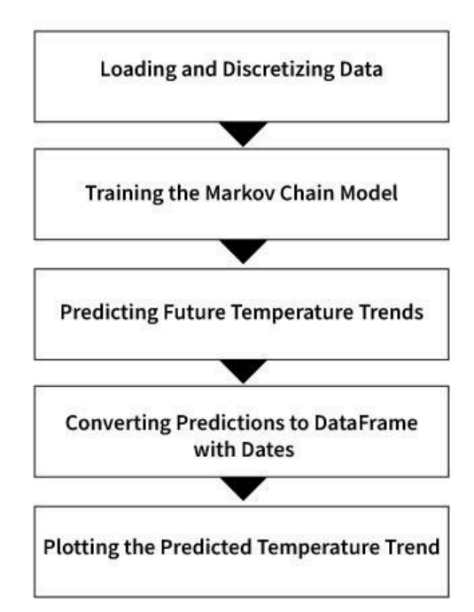

Fig 2: Block Diagram of system workflow

# Expected Outcomes

**Comprehensive Temperature Analysis:** The project aims to provide a thorough analysis of the temperature distribution within Kathmandu City, including variations across different seasons and provides insights about the monthly and yearly pattern of the temperature of Kathmandu city at 2-meter surface range.

**Development of Forecasting Models:** The project will develop predictive models for forecasting temperature distribution in Kathmandu City. The predictive model will utilize historical temperature data, meteorological factors, and possibly machine learning algorithms to generate accurate forecasts for future temperature trends.

# Working Schedule

The table below shows the working schedule for this research project.

|  |  |  |  |  |  |  |  |  |  |
| --- | --- | --- | --- | --- | --- | --- | --- | --- | --- |
| **Task** | **Week 1** | **Week 2** | **Week 3** | **Week 4** | **Week 5** | **Week 6** | **Week 7** | **Week 8** | **Week 9** |
| Project Planning and Preparation |  |  |  |  |  |  |  |  |  |
| Literature Review |  |  |  |  |  |  |  |  |  |
| Data Collection and Processing |  |  |  |  |  |  |  |  |  |
| Analysis of Temperature Distribution |  |  |  |  |  |  |  |  |  |
| Development of Predictive Models |  |  |  |  |  |  |  |  |  |
| Key Findings and Fine Tuning |  |  |  |  |  |  |  |  |  |
| Report Writing and Finalization |  |  |  |  |  |  |  |  |  |

Table 1: Working Schedule of the project

# References

GeeksforGeeks. (2023, July 31). Markov Chain [Image]. In Markov Chains in NLP. Retrieved from <https://www.geeksforgeeks.org/markov-chains-in-nlp/>

Maharjan, S., & Regmi, R.P. (2014). Grid based temperature and relative humidity distribution map of the Kathmandu valley. Journal of Institute of Science and Technology, 19(1), 7-13. Retrieved from portal.tu.edu.np

Magar, D.S., Magar, R.K.S., & Chidi, C.L. (2021). Assessment of urban heat island in Kathmandu valley (1999-2017). The Geographical Journal of Nepal, 14, 1-20. DOI: https://doi.org/10.3126/gjn.v14i0.35544